ReactJS Hands-On Labs
Labs 10-13: JSX, Events, Conditional Rendering & Lists

Lab 10: officespacerentalapp
Objective: use JSX to build elements, add attributes, work with objects/arrays and apply inline CSS to conditionally colour the rent based on its value.

What I did
Created a new React app called officespacerentalapp. Built one component (OfficeItem) that takes name, rent and address as props, and used .map() on an array of office objects to render the list. For the colour logic I just used a ternary - if rent < 60000 show red else green, applied via inline style since that's what the lab asked for.

Code

src/App.js
import React from "react";
import "./App.css";

const officeSpaceList = [
{ id: 1, name: "Kohinoor Business Park", rent: 45000, address: "Andheri East, Mumbai" },
{ id: 2, name: "Prestige Tech Tower", rent: 72000, address: "Whitefield, Bangalore" },
{ id: 3, name: "DLF Cyber City", rent: 58000, address: "Sector 24, Gurugram" },
{ id: 4, name: "Salarpuria Sattva", rent: 85000, address: "Koramangala, Bangalore" }
];

function OfficeItem(props) {
// apply inline CSS - red if below 60000, green if above
const rentColor = props.rent < 60000 ? "red" : "green";

return (
<div className="office-card">
<h3>{props.name}</h3>
<p>
Rent:{" "}
<span style={{ color: rentColor, fontWeight: "bold" }}>
Rs. {props.rent}
</span>
</p>
<p>Address: {props.address}</p>
</div>
);
}

function App() {
return (
<div className="container">
<h1>Office Space Rental</h1>
<img className="office-img" src={require("./office.jpg")} alt="office space" />

{officeSpaceList.map((office) => (
<OfficeItem
key={office.id}
name={office.name}
rent={office.rent}
address={office.address}
/>
))}
</div>
);
}

export default App;

src/index.js
import React from "react";
import ReactDOM from "react-dom/client";
import App from "./App";

const root = ReactDOM.createRoot(document.getElementById("root"));
root.render(<App />);

Output
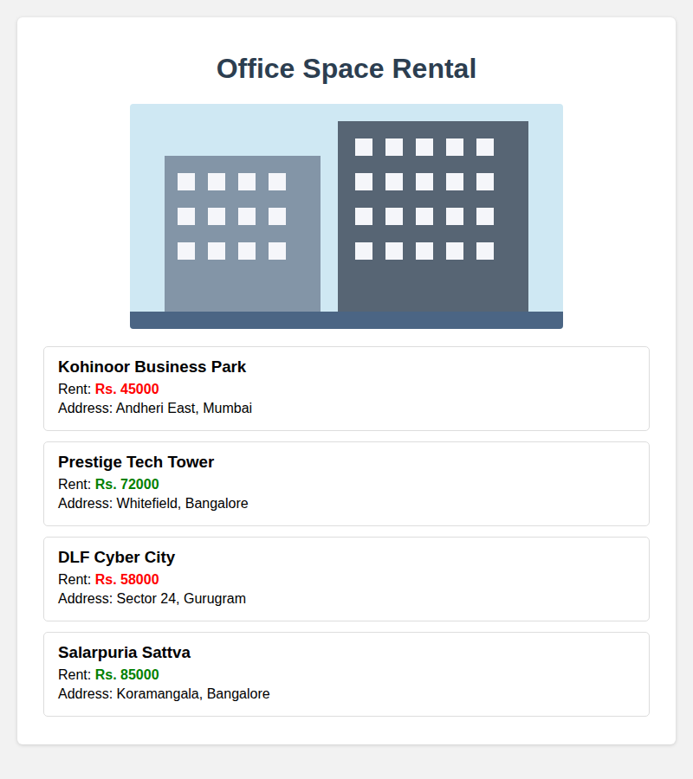
Fig 10.1 - officespacerentalapp running on localhost:3000

Lab 11: eventexamplesapp
Objective: handle events in React (onClick), understand synthetic events, pass arguments to handlers, and use the this keyword / hooks state.

What I did
Made 4 small components in one app - a Counter with Increment/Decrement (Increment calls two functions - one to bump the count and one to show a hello message), a Say Welcome button that passes an argument to its handler, a synthetic event example (onPress shows 'I was clicked'), and a CurrencyConvertor that converts INR to EUR on form submit using handleSubmit.

Code

src/Counter.js
import React, { useState } from "react";

function Counter() {
const [count, setCount] = useState(0);
const [message, setMessage] = useState("");

const sayHello = () => {
setMessage("Hello! Counter was incremented.");
};

// Increment button calls 2 methods
const handleIncrement = () => {
setCount(count + 1);
sayHello();
};

const handleDecrement = () => {
setCount(count - 1);
setMessage("");
};

return (
<div className="card">
<h2>Counter Example</h2>
<p>Count: <b>{count}</b></p>
<button onClick={handleIncrement}>Increment</button>
<button onClick={handleDecrement}>Decrement</button>
{message && <p className="msg">{message}</p>}
</div>
);
}

export default Counter;

src/WelcomeButton.js
import React, { useState } from "react";

function WelcomeButton() {
const [greeting, setGreeting] = useState("");

// handler takes an argument
const sayWelcome = (name) => {
setGreeting(`Welcome, ${name}!`);
};

return (
<div className="card">
<h2>Say Welcome Example</h2>
<button onClick={() => sayWelcome("welcome")}>Say Welcome</button>
{greeting && <p className="msg">{greeting}</p>}
</div>
);
}

export default WelcomeButton;

src/SyntheticEventExample.js
import React, { useState } from "react";

function SyntheticEventExample() {
const [clicked, setClicked] = useState("");

// e here is React's SyntheticEvent, wraps the native browser event
const onPress = (e) => {
setClicked("I was clicked");
};

return (
<div className="card">
<h2>Synthetic Event Example</h2>
<button onClick={onPress}>Click Me</button>
{clicked && <p className="msg">{clicked}</p>}
</div>
);
}

export default SyntheticEventExample;

src/CurrencyConvertor.js
import React, { useState } from "react";

function CurrencyConvertor() {
const [rupees, setRupees] = useState("");
const [euro, setEuro] = useState(null);
const rate = 0.011; // approx INR to EUR

const handleSubmit = (e) => {
e.preventDefault();
const value = parseFloat(rupees) || 0;
setEuro((value * rate).toFixed(2));
};

return (
<div className="card">
<h2>Currency Convertor</h2>
<form onSubmit={handleSubmit}>
<input
type="number"
placeholder="Enter INR"
value={rupees}
onChange={(e) => setRupees(e.target.value)}
/>
<button type="submit">Convert</button>
</form>
{euro !== null && <p className="msg">₹{rupees} = €{euro}</p>}
</div>
);
}

export default CurrencyConvertor;

src/App.js
import React from "react";
import Counter from "./Counter";
import WelcomeButton from "./WelcomeButton";
import SyntheticEventExample from "./SyntheticEventExample";
import CurrencyConvertor from "./CurrencyConvertor";
import "./App.css";

function App() {
return (
<div className="container">
<Counter />
<WelcomeButton />
<SyntheticEventExample />
<CurrencyConvertor />
</div>
);
}

export default App;

Output
Clicked Increment twice, Say Welcome, Click Me, and converted ₹5000:
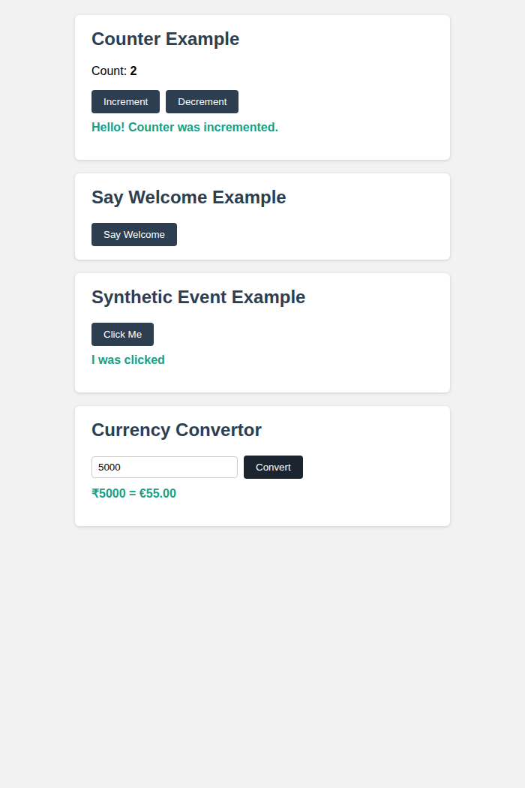
Fig 11.1 - eventexamplesapp after triggering all events

Lab 12: ticketbookingapp
Objective: conditional rendering - show a Guest page vs a User page depending on login state.

What I did
Kept a single isLoggedIn state in App. Guest page just lists the flights (view only). Once you click Login it flips isLoggedIn to true and the User page shows up with a Book Now button on each flight. Logout flips it back. Used a simple ternary in the JSX to switch between LoginButton/LogoutButton and GuestPage/UserPage.

Code

src/App.js
import React, { useState } from "react";
import GuestPage from "./GuestPage";
import UserPage from "./UserPage";
import "./App.css";

function LoginButton(props) {
return <button onClick={props.onClick}>Login</button>;
}

function LogoutButton(props) {
return <button onClick={props.onClick}>Logout</button>;
}

function App() {
const [isLoggedIn, setIsLoggedIn] = useState(false);

return (
<div className="container">
<div className="navbar">
<h1>Ticket Booking App</h1>
{isLoggedIn ? (
<LogoutButton onClick={() => setIsLoggedIn(false)} />
) : (
<LoginButton onClick={() => setIsLoggedIn(true)} />
)}
</div>

{isLoggedIn ? <UserPage /> : <GuestPage />}
</div>
);
}

export default App;

src/flights.js
export const flights = [
{ id: 1, name: "IndiGo 6E-202", from: "Delhi", to: "Mumbai", price: 4500 },
{ id: 2, name: "Air India AI-101", from: "Mumbai", to: "Bangalore", price: 3800 },
{ id: 3, name: "Vistara UK-955", from: "Chennai", to: "Delhi", price: 5200 },
];

src/GuestPage.js
import React from "react";
import { flights } from "./flights";

function GuestPage() {
return (
<div>
<p>You are browsing as a <b>Guest</b>. Please login to book tickets.</p>
{flights.map((f) => (
<div className="flight" key={f.id}>
<h4>{f.name}</h4>
<p>{f.from} -&gt; {f.to} | Rs. {f.price}</p>
</div>
))}
</div>
);
}

export default GuestPage;

src/UserPage.js
import React, { useState } from "react";
import { flights } from "./flights";

function UserPage() {
const [booked, setBooked] = useState(null);

return (
<div>
<p className="welcome">Welcome back! You can now book tickets.</p>
{flights.map((f) => (
<div className="flight" key={f.id}>
<h4>{f.name}</h4>
<p>{f.from} -&gt; {f.to} | Rs. {f.price}</p>
<button className="book-btn" onClick={() => setBooked(f.name)}>
Book Now
</button>
</div>
))}
{booked && <p className="welcome">Ticket booked for {booked}!</p>}
</div>
);
}

export default UserPage;

Output

Guest page (before login)
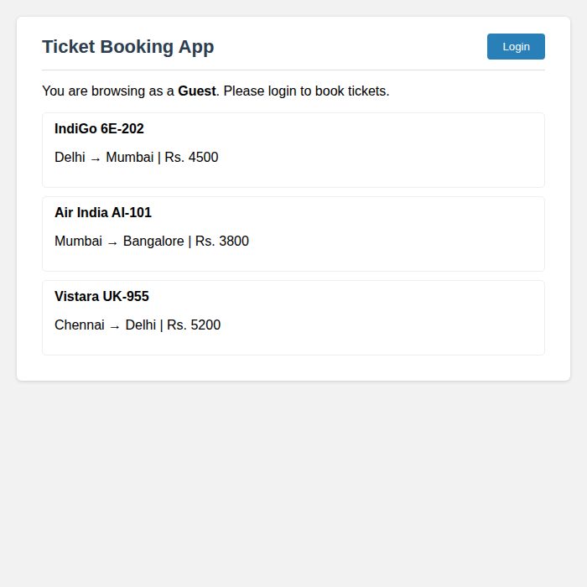
Fig 12.1 - Guest page, only viewing flights, no booking option

User page (after login + booking)
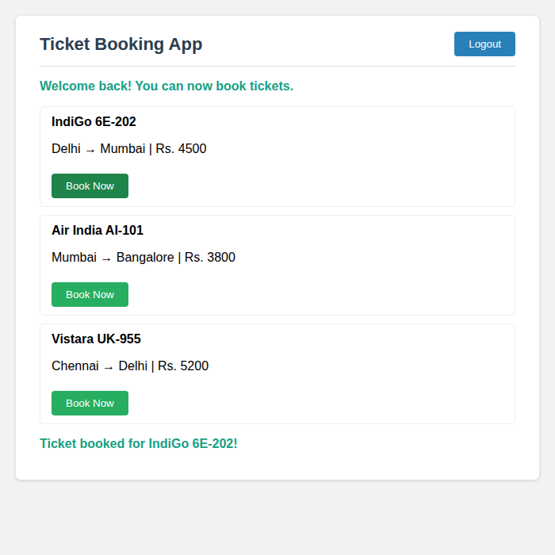
Fig 12.2 - User page after clicking Login and booking a flight

Lab 13: bloggerapp
Objective: implement conditional rendering in as many ways as possible across 3 components - Book Details, Blog Details, Course Details.

What I did
Used a different conditional rendering technique in each component so it covers all the ways mentioned in class:
- BookDetails - if/else stored in an element variable, then rendered
- BlogDetails - inline ternary operator directly in JSX
- CourseDetails - && short-circuit operator to conditionally show/hide
Also added toggle buttons in App.js just so I could actually demo the conditional rendering changing on screen instead of it being static.

Code

src/BookDetails.js (if/else -> element variable)
import React from "react";

function BookDetails(props) {
let content;
if (props.available) {
content = <p>"Atomic Habits" is available in the library.</p>;
} else {
content = <p>"Atomic Habits" is currently checked out.</p>;
}

return (
<div className="section">
<h3>Book Details</h3>
{content}
</div>
);
}

export default BookDetails;

src/BlogDetails.js (ternary operator)
import React from "react";

function BlogDetails(props) {
return (
<div className="section">
<h3>Blog Details</h3>
<p>
"Understanding React Hooks"
{props.isNew ? <span className="badge new">New</span> : null}
</p>
{props.isNew ? <p>Published today.</p> : <p>Published last week.</p>}
</div>
);
}

export default BlogDetails;

src/CourseDetails.js (&& operator)
import React from "react";

function CourseDetails(props) {
return (
<div className="section">
<h3>Course Details</h3>
<p>"React for Beginners"</p>
{props.seatsLeft > 0 && (
<p>Seats available: {props.seatsLeft} <span className="badge avail">Enroll now</span></p>
)}
{props.seatsLeft === 0 && <p>Course is full.</p>}
</div>
);
}

export default CourseDetails;

src/App.js
import React, { useState } from "react";
import BookDetails from "./BookDetails";
import BlogDetails from "./BlogDetails";
import CourseDetails from "./CourseDetails";
import "./App.css";

function App() {
const [available, setAvailable] = useState(true);
const [isNew, setIsNew] = useState(true);
const [seatsLeft, setSeatsLeft] = useState(5);

return (
<div className="container">
<h1>Blogger App</h1>
<BookDetails available={available} />
<BlogDetails isNew={isNew} />
<CourseDetails seatsLeft={seatsLeft} />

<div className="section">
<h3>Controls (toggle conditional rendering)</h3>
<button onClick={() => setAvailable(!available)}>Toggle Book Availability</button>
<button onClick={() => setIsNew(!isNew)}>Toggle Blog New Flag</button>
<button onClick={() => setSeatsLeft(seatsLeft > 0 ? 0 : 5)}>Toggle Course Seats</button>
</div>
</div>
);
}

export default App;

Output
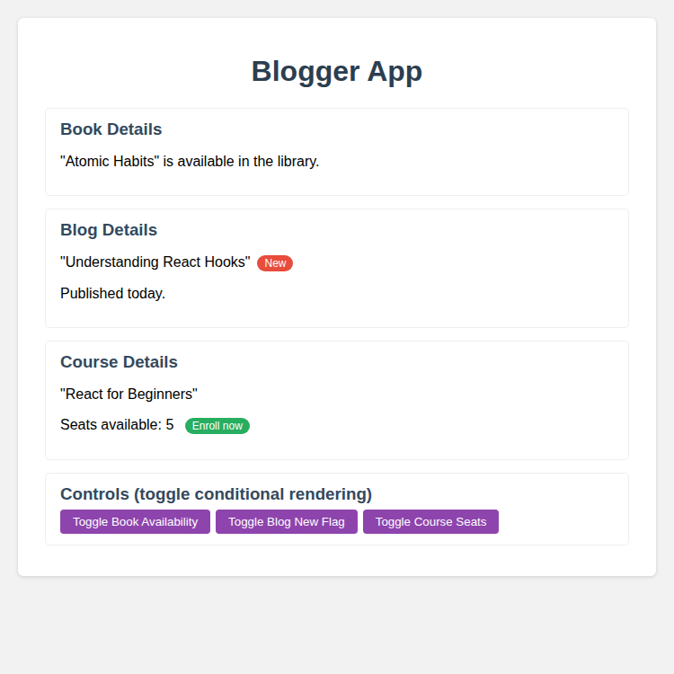
Fig 13.1 - bloggerapp with all 3 conditional rendering techniques

